Modern Database Management, 13e (Hoffer)
Chapter 14 Object-Oriented Data Modeling

1) A(n) ________ is a concept, abstraction, or thing that has a state, behavior, and identity.
A) relationship
B) attribute
C) key
D) object
Answer: D
LO: 14.2: Describe the activities in the different phases of the object-oriented development life cycle.
Difficulty: Easy
Classification: Concept
AACSB: Information Technology

2) The object-oriented systems development cycle consists of:
A) two phases.
B) three phases.
C) four phases.
D) five phases.
Answer: B
LO: 14.2: Describe the activities in the different phases of the object-oriented development life cycle.
Difficulty: Easy
Classification: Concept
AACSB: Information Technology

3) A model of a real-world application and associated properties are created in the:
A) analysis phase.
B) design phase.
C) implementation phase.
D) evaluation phase.
Answer: A
LO: 14.2: Describe the activities in the different phases of the object-oriented development life cycle.
Difficulty: Easy
Classification: Concept
AACSB: Information Technology

4) A(n) ________ encompasses an object's properties and the values of those properties.
A) state
B) attribute
C) method
D) behavior
Answer: A
LO: 14.2: Describe the activities in the different phases of the object-oriented development life cycle.
Difficulty: Easy
Classification: Concept
AACSB: Information Technology
5) Which of the following is a reason for using an object-oriented design?
A) The analysis model is not formal enough to be implemented in a programming language.
B) The actual system is not adapted to the environment in which the system will actually be implemented.
C) Documentation is provided.
D) Traditional ERD is preferred.
Answer: A
LO: 14.3: State the advantages of object-oriented modeling vis-à-vis structured approaches.
Difficulty: Easy
Classification: Concept
AACSB: Information Technology

6) All of the following are benefits of object-oriented modeling EXCEPT:
A) the ability to tackle more challenging problem domains.
B) increased consistency among analysis, design, and programming activities.
C) decreased communication among the users, analysts, designers, and programmers.
D) reusability of analysis, design, and programming results.
Answer: C
LO: 14.3: State the advantages of object-oriented modeling vis-à-vis structured approaches.
Difficulty: Easy
Classification: Concept
AACSB: Information Technology

7) Both E-R model and object-oriented models are centered around:
A) objects.
B) encapsulation.
C) polymorphism.
D) object diagrams.
Answer: A
LO: 14.4: Compare the object-oriented model with the E-R and EER models.
Difficulty: Easy
Classification: Concept
AACSB: Information Technology

8) Object-oriented model objects differ from E-R models because:
A) OO store data.
B) OO allow data types.
C) OO objects exhibit behavior.
D) OO stores information.
Answer: C
LO: 14.4: Compare the object-oriented model with the E-R and EER models.
Difficulty: Easy
Classification: Concept
AACSB: Information Technology
9) The Unified Modeling Language:
A) is a notation useful for graphically depicting an object-oriented analysis or design model.
B) is used in traditional ERD modeling.
C) was developed by E.F. Codd.
D) is a SQL sublanguage.
Answer: A
LO: 14.5: Model a real-world domain by using a Unified Modeling Language (UML) class diagram.
Difficulty: Easy
Classification: Concept
AACSB: Information Technology

10) A diagram that shows the static structure of an object-oriented model is called a(n):
A) structure diagram.
B) class diagram.
C) entity diagram.
D) data flow diagram.
Answer: B
LO: 14.5: Model a real-world domain by using a Unified Modeling Language (UML) class diagram.
Difficulty: Easy
Classification: Concept
AACSB: Information Technology

11) Which of the following refers to a set of objects that share common structures and behaviors?
A) Supertype
B) Object class
C) Model
D) Entity group
Answer: B
LO: 14.5: Model a real-world domain by using a Unified Modeling Language (UML) class diagram.
Difficulty: Moderate
Classification: Concept
AACSB: Information Technology

12) Which of the following is a function or service provided by all instances of a class?
A) Operation
B) Implementation
C) Class group
D) Query
Answer: A
LO: 14.5: Model a real-world domain by using a Unified Modeling Language (UML) class diagram.
Difficulty: Easy
Classification: Concept
AACSB: Information Technology
13) An operation that creates a new instance of a class is called a(n):
A) query operation.
B) update operation.
C) scope operation.
D) constructor operation.
Answer: D
LO: 14.5: Model a real-world domain by using a Unified Modeling Language (UML) class diagram.
Difficulty: Easy
Classification: Concept
AACSB: Information Technology

14) Which of the following operations does NOT alter the state of an object?
A) Update
B) Query
C) Constructor
D) Class-Scope
Answer: B
LO: 14.5: Model a real-world domain by using a Unified Modeling Language (UML) class diagram.
Difficulty: Easy
Classification: Concept
AACSB: Information Technology

15) ________ is the technique of hiding the internal implementation details of an object from its external view.
A) Grouping
B) Encapsulation
C) Classification
D) Mining
Answer: B
LO: 14.5: Model a real-world domain by using a Unified Modeling Language (UML) class diagram.
Difficulty: Easy
Classification: Concept
AACSB: Information Technology

16) An operation that applies to a class rather than an object instance is a(n):
A) constructor operation.
B) query operation.
C) class-scope operation.
D) update operation.
Answer: C
LO: 14.5: Model a real-world domain by using a Unified Modeling Language (UML) class diagram.
Difficulty: Easy
Classification: Concept
AACSB: Information Technology
17) A(n) ________ is shown as a solid line between the participating classes.
A) connector
B) update
C) entity
D) association
Answer: D
LO: 14.5: Model a real-world domain by using a Unified Modeling Language (UML) class diagram.
Difficulty: Easy
Classification: Concept
AACSB: Information Technology

18) The end of an association where it connects to a class is called a(n):
A) connector.
B) terminator.
C) initiator.
D) association role.
Answer: D
LO: 14.5: Model a real-world domain by using a Unified Modeling Language (UML) class diagram.
Difficulty: Easy
Classification: Concept
AACSB: Information Technology

19) ________ indicates how many objects participate in a given relationship.
A) Bound
B) Multiplicity
C) Role
D) Relationship
Answer: B
LO: 14.5: Model a real-world domain by using a Unified Modeling Language (UML) class diagram.
Difficulty: Moderate
Classification: Concept
AACSB: Information Technology
20) In the figure below, which of the following is true?

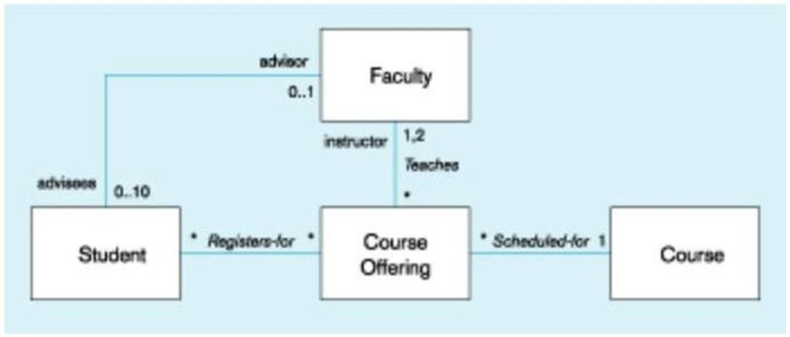

A) A faculty may advise only one student.
B) A faculty may advise up to a maximum of 10 students.
C) A course offering may be offered for multiple courses.
D) A student can have more than one advisor.
Answer: B
LO: 14.5: Model a real-world domain by using a Unified Modeling Language (UML) class diagram.
Difficulty: Moderate
Classification: Application
AACSB: Information Technology

21) An association ________ is an association that has attributes or operations of its own.
A) link
B) group
C) class
D) body
Answer: C
LO: 14.5: Model a real-world domain by using a Unified Modeling Language (UML) class diagram.
Difficulty: Easy
Classification: Concept
AACSB: Information Technology
22) In the figure below, which of the following is true?

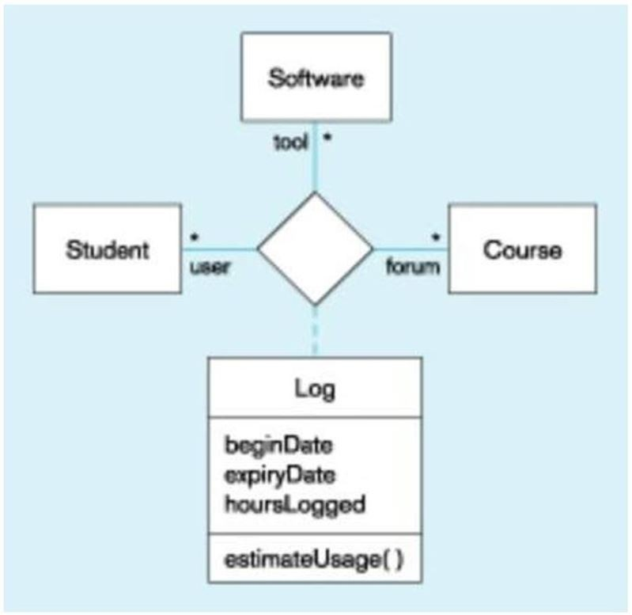

A) Students use various software tools for different courses.
B) Students can only register for one course.
C) Students use only one type of software.
D) Each course uses specific software.
Answer: A
LO: 14.5: Model a real-world domain by using a Unified Modeling Language (UML) class diagram.
Difficulty: Moderate
Classification: Application
AACSB: Information Technology

23) A graph of instances that are compatible within a class diagram is called a(n):
A) object group.
B) method chart.
C) object diagram.
D) ERD.
Answer: C
LO: 14.6: Provide a snapshot of the detailed state of a system at a point in time, using a UML object diagram.
Difficulty: Easy
Classification: Concept
AACSB: Information Technology
24) The following figure is an example of a(n):

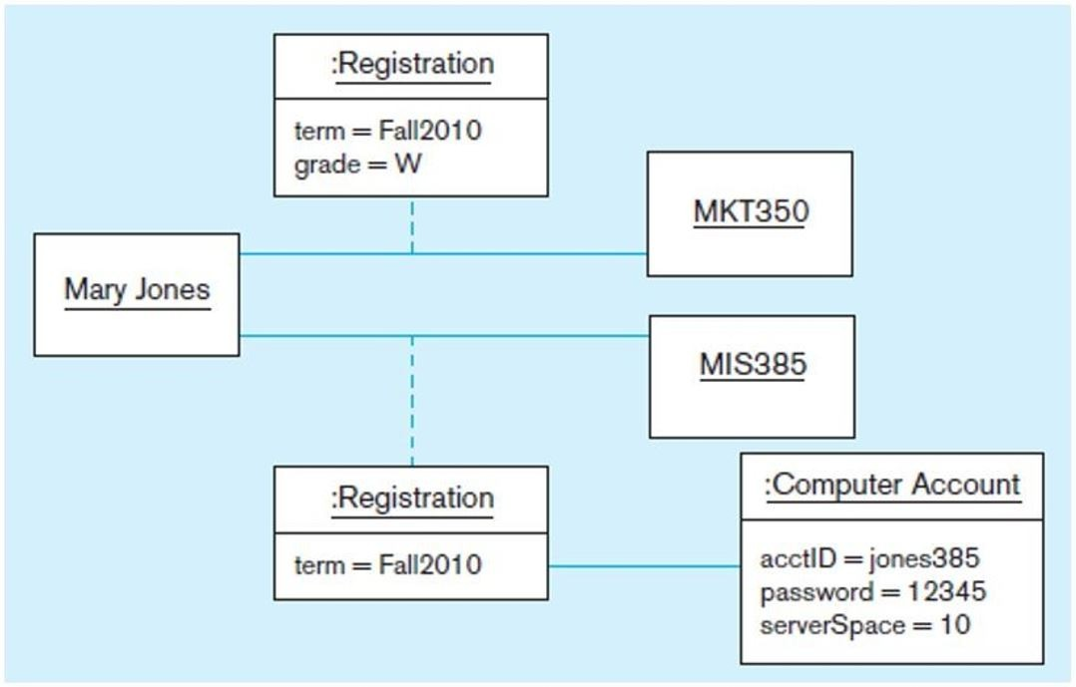

A) class diagram.
B) method chart.
C) object diagram.
D) ERD.
Answer: C
LO: 14.6: Provide a snapshot of the detailed state of a system at a point in time, using a UML object diagram.
Difficulty: Easy
Classification: Application
AACSB: Information Technology
25) In the following diagram, ________ objects are present (i.e., :Registration).

A) link
B) object
C) XML
D) ERD
Answer: A
LO: 14.6: Provide a snapshot of the detailed state of a system at a point in time, using a UML object diagram.
Difficulty: Easy
Classification: Application
AACSB: Information Technology

26) A class that has direct instances is called a(n) ________ class.
A) abstract
B) multiplicity
C) large
D) concrete
Answer: D
LO: 14.7: Recognize when to use generalization, aggregation, and composition relationships.
Difficulty: Easy
Classification: Concept
AACSB: Information Technology
27) According to the UML Notation Guide, overlapping means:
A) a descendant may be descended from more than one of the subclasses.
B) a descendant may not be descended from more than one of the subclasses.
C) all subclasses have been specified, and no others are expected.
D) the list of objects is stable, but relationships will change.
Answer: A
LO: 14.7: Recognize when to use generalization, aggregation, and composition relationships.
Difficulty: Moderate
Classification: Concept
AACSB: Information Technology

28) According to the UML Notation Guide, complete means:
A) a descendant may come from more than one supertype.
B) a descendant may be not descended from more than one of the subclasses.
C) all subclasses have been specified, and no others are expected.
D) the list of objects is NOT stable.
Answer: C
LO: 14.7: Recognize when to use generalization, aggregation, and composition relationships.
Difficulty: Moderate
Classification: Concept
AACSB: Information Technology

29) A(n) ________ is an attribute of a class that specifies a value common to an entire class.
A) completion attribute
B) class-scope attribute
C) overall descriptor
D) summary descriptor
Answer: B
LO: 14.7: Recognize when to use generalization, aggregation, and composition relationships.
Difficulty: Easy
Classification: Concept
AACSB: Information Technology

30) A(n) ________ defines the form or protocol of an operation, but not its implementation.
A) meta-operation
B) inquisitor
C) abstract operation
D) operation descriptor
Answer: C
LO: 14.7: Recognize when to use generalization, aggregation, and composition relationships.
Difficulty: Easy
Classification: Concept
AACSB: Information Technology
31) A ________ is the implementation of an operation.
A) meta-operation
B) method
C) query
D) constructor
Answer: B
LO: 14.7: Recognize when to use generalization, aggregation, and composition relationships.
Difficulty: Easy
Classification: Concept
AACSB: Information Technology

32) ________ means that the same operation can apply to two or more classes in different ways.
A) Polymorphism
B) Inheritance
C) Combined operations
D) Checkpoint
Answer: A
LO: 14.7: Recognize when to use generalization, aggregation, and composition relationships.
Difficulty: Moderate
Classification: Concept
AACSB: Information Technology

33) The process of replacing a method inherited from a superclass by a more specific implementation of the method in a subclass is called:
A) inheritance.
B) encapsulation.
C) polymorphism.
D) overriding.
Answer: D
LO: 14.7: Recognize when to use generalization, aggregation, and composition relationships.
Difficulty: Moderate
Classification: Concept
AACSB: Information Technology

34) When an object is an instance of more than one class, it is called:
A) multiplicity.
B) polymorphism.
C) multiple classification.
D) multiple associations.
Answer: C
LO: 14.7: Recognize when to use generalization, aggregation, and composition relationships.
Difficulty: Moderate
Classification: Concept
AACSB: Information Technology
35) In the figure below, what relationship is shown?

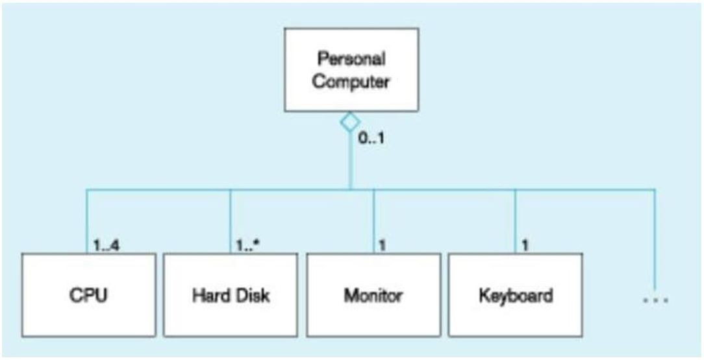

A) Overlaps
B) Disjoints
C) Rejoinders
D) Aggregation
Answer: D
LO: 14.7: Recognize when to use generalization, aggregation, and composition relationships.
Difficulty: Moderate
Classification: Application
AACSB: Information Technology

36) A part object which belongs to only one whole object and which lives and dies with the whole object is called a:
A) dependent.
B) weak entity.
C) composition.
D) declarative.
Answer: C
LO: 14.7: Recognize when to use generalization, aggregation, and composition relationships.
Difficulty: Moderate
Classification: Concept
AACSB: Information Technology

37) {disjoint, complete} is an example of a UML:
A) expansion.
B) HTML link.
C) business rule constraint.
D) database clause.
Answer: C
LO: 14.8: Specify different types of business rules in a class diagram.
Difficulty: Easy
Classification: Application
AACSB: Information Technology
38) When specifying a business rule between graphical symbols, a ________ is drawn from one element to the other.
A) dashed arrow
B) dashed asterisk
C) highlighted union
D) highlighted intersect
Answer: A
LO: 14.8: Specify different types of business rules in a class diagram.
Difficulty: Easy
Classification: Concept
AACSB: Information Technology

39) The implementation of an operation is called a(n):
A) attribute.
B) class.
C) method.
D) object.
Answer: C
LO: 14.7: Recognize when to use generalization, aggregation, and composition relationships.
Difficulty: Easy
Classification: Concept
AACSB: Information Technology

40) A(n) ________ is a named relationship between or among classes.
A) association
B) named relationship
C) assumption
D) attribute
Answer: A
LO: 14.5: Model a real-world domain by using a Unified Modeling Language (UML) class diagram.
Difficulty: Moderate
Classification: Concept
AACSB: Information Technology

41) A state represents how an object acts.
Answer: FALSE
LO: 14.2: Describe the activities in the different phases of the object-oriented development life cycle.
Difficulty: Moderate
Classification: Concept
AACSB: Information Technology

42) The object-oriented systems development cycle consists of four phases.
Answer: FALSE
LO: 14.2: Describe the activities in the different phases of the object-oriented development life cycle.
Difficulty: Easy
Classification: Concept
AACSB: Information Technology
43) Both E-R model and object-oriented models are centered around objects.
Answer: TRUE
LO: 14.4: Compare the object-oriented model with the E-R and EER models.
Difficulty: Easy
Classification: Concept
AACSB: Information Technology

44) Both Object-oriented and E-R objects exhibit behaviors.
Answer: FALSE
LO: 14.4: Compare the object-oriented model with the E-R and EER models.
Difficulty: Moderate
Classification: Concept
AACSB: Information Technology

45) An object encapsulates both data and behavior.
Answer: TRUE
LO: 14.3: State the advantages of object-oriented modeling vis-à-vis structured approaches.
Difficulty: Easy
Classification: Concept
AACSB: Information Technology

46) A class diagram shows the dynamic structure of an object-oriented model.
Answer: FALSE
LO: 14.3: State the advantages of object-oriented modeling vis-à-vis structured approaches.
Difficulty: Easy
Classification: Concept
AACSB: Information Technology

47) A constructor operation does not alter an instance of a class.
Answer: FALSE
LO: 14.5: Model a real-world domain by using a Unified Modeling Language (UML) class diagram.
Difficulty: Easy
Classification: Concept
AACSB: Information Technology

48) A class-scope operation applies to a class rather than an object instance.
Answer: TRUE
LO: 14.5: Model a real-world domain by using a Unified Modeling Language (UML) class diagram.
Difficulty: Easy
Classification: Concept
AACSB: Information Technology

49) An object class is a set of objects that share a common structure and behavior.
Answer: TRUE
LO: 14.5: Model a real-world domain by using a Unified Modeling Language (UML) class diagram.
Difficulty: Easy
Classification: Concept
AACSB: Information Technology
50) An operation is a function or service that is provided by all of the classes.
Answer: TRUE
LO: 14.5: Model a real-world domain by using a Unified Modeling Language (UML) class diagram.
Difficulty: Easy
Classification: Concept
AACSB: Information Technology

51) State encompasses an object's properties and the values of those properties.
Answer: TRUE
LO: 14.5: Model a real-world domain by using a Unified Modeling Language (UML) class diagram.
Difficulty: Easy
Classification: Concept
AACSB: Information Technology

52) An entity that has a well-defined role in the application domain and has a state, behavior, and identity is called an object.
Answer: FALSE
LO: 14.5: Model a real-world domain by using a Unified Modeling Language (UML) class diagram.
Difficulty: Moderate
Classification: Concept
AACSB: Information Technology

53) Encapsulation is the technique of hiding the internal implementation details of an object from its external view.
Answer: TRUE
LO: 14.5: Model a real-world domain by using a Unified Modeling Language (UML) class diagram.
Difficulty: Moderate
Classification: Concept
AACSB: Information Technology

54) An association role is the end of an association where it connects to a class.
Answer: TRUE
LO: 14.5: Model a real-world domain by using a Unified Modeling Language (UML) class diagram.
Difficulty: Easy
Classification: Concept
AACSB: Information Technology

55) Each role has a duplicity, which indicates how many objects participate in a given relationship.
Answer: FALSE
LO: 14.5: Model a real-world domain by using a Unified Modeling Language (UML) class diagram.
Difficulty: Easy
Classification: Concept
AACSB: Information Technology

56) The most common multiplicities are 0,1, *, and 1.
Answer: TRUE
LO: 14.5: Model a real-world domain by using a Unified Modeling Language (UML) class diagram.
Difficulty: Moderate
Classification: Concept
AACSB: Information Technology
57) A ternary relationship can easily be replaced by three binary relationships.
Answer: FALSE
LO: 14.5: Model a real-world domain by using a Unified Modeling Language (UML) class diagram.
Difficulty: Moderate
Classification: Concept
AACSB: Information Technology

58) An association class is an association that participates in no relationships.
Answer: FALSE
LO: 14.5: Model a real-world domain by using a Unified Modeling Language (UML) class diagram.
Difficulty: Moderate
Classification: Concept
AACSB: Information Technology

59) An association class is similar to an associative entity in the E-R model.
Answer: TRUE
LO: 14.5: Model a real-world domain by using a Unified Modeling Language (UML) class diagram.
Difficulty: Moderate
Classification: Concept
AACSB: Information Technology

60) A derived attribute, association, or role is one that can be computed or derived from other attributes, associations, or roles.
Answer: TRUE
LO: 14.5: Model a real-world domain by using a Unified Modeling Language (UML) class diagram.
Difficulty: Moderate
Classification: Concept
AACSB: Information Technology

61) An instance of a subclass is not always an instance of its superclass.
Answer: FALSE
LO: 14.5: Model a real-world domain by using a Unified Modeling Language (UML) class diagram.
Difficulty: Moderate
Classification: Concept
AACSB: Information Technology

62) A class diagram shows the static structure of an object-oriented model.
Answer: TRUE
LO: 14.5: Model a real-world domain by using a Unified Modeling Language (UML) class diagram.
Difficulty: Easy
Classification: Concept
AACSB: Information Technology

63) A UML is a graph of instances that are compatible with a given class diagram.
Answer: FALSE
LO: 14.5: Model a real-world domain by using a Unified Modeling Language (UML) class diagram.
Difficulty: Easy
Classification: Concept
AACSB: Information Technology
64) It is only through an operation that other objects can access or manipulate information stored in an object.
Answer: TRUE
LO: 14.5: Model a real-world domain by using a Unified Modeling Language (UML) class diagram.
Difficulty: Moderate
Classification: Concept
AACSB: Information Technology

65) Encapsulation is the technique of hiding the internal implementation details of an object from its external view.
Answer: TRUE
LO: 14.5: Model a real-world domain by using a Unified Modeling Language (UML) class diagram.
Difficulty: Moderate
Classification: Concept
AACSB: Information Technology

66) A destructor operation creates a new instance of a class.
Answer: FALSE
LO: 14.5: Model a real-world domain by using a Unified Modeling Language (UML) class diagram.
Difficulty: Easy
Classification: Concept
AACSB: Information Technology

67) An update operation has side effects since it alters the state of an object.
Answer: TRUE
LO: 14.5: Model a real-world domain by using a Unified Modeling Language (UML) class diagram.
Difficulty: Moderate
Classification: Concept
AACSB: Information Technology

68) A query operation does not alter the state of an object.
Answer: TRUE
LO: 14.5: Model a real-world domain by using a Unified Modeling Language (UML) class diagram.
Difficulty: Moderate
Classification: Concept
AACSB: Information Technology

69) An association role is the end of an association where it connects to a class.
Answer: TRUE
LO: 14.5: Model a real-world domain by using a Unified Modeling Language (UML) class diagram.
Difficulty: Moderate
Classification: Concept
AACSB: Information Technology

70) A duplicity specification in a class diagram is shown as a text string representing an interval (or intervals) of integers.
Answer: FALSE
LO: 14.5: Model a real-world domain by using a Unified Modeling Language (UML) class diagram.
Difficulty: Easy
Classification: Concept
AACSB: Information Technology
71) An association that has its own attributes or operations or that participates in relationships with other classes is called an association class.
Answer: TRUE
LO: 14.5: Model a real-world domain by using a Unified Modeling Language (UML) class diagram.
Difficulty: Moderate
Classification: Concept
AACSB: Information Technology

72) A deprived attribute, role, or association is one that can be computed from other attributes, roles, or associations.
Answer: FALSE
LO: 14.5: Model a real-world domain by using a Unified Modeling Language (UML) class diagram.
Difficulty: Moderate
Classification: Concept
AACSB: Information Technology

73) A graph of instances that are compatible within a class diagram is called an object diagram.
Answer: TRUE
LO: 14.6: Provide a snapshot of the detailed state of a system at a point in time, using a UML object diagram.
Difficulty: Easy
Classification: Concept
AACSB: Information Technology

74) A class that can have direct instances is called an abstract class.
Answer: FALSE
LO: 14.7: Recognize when to use generalization, aggregation, and composition relationships.
Difficulty: Easy
Classification: Concept
AACSB: Information Technology

75) According to the UML Notation Guide, the term disjoint means that a descendent may not be descended from more than one of the subclasses.
Answer: TRUE
LO: 14.7: Recognize when to use generalization, aggregation, and composition relationships.
Difficulty: Moderate
Classification: Concept
AACSB: Information Technology

76) A class-scope attribute is an attribute of a class that specifies a value common to an instance of a class.
Answer: FALSE
LO: 14.7: Recognize when to use generalization, aggregation, and composition relationships.
Difficulty: Moderate
Classification: Concept
AACSB: Information Technology

77) In addition to specifying the multiplicity of an association role, you can also specify other properties, for example, if the objects playing the role are ordered or not.
Answer: TRUE
LO: 14.7: Recognize when to use generalization, aggregation, and composition relationships.
Difficulty: Moderate
Classification: Concept
AACSB: Information Technology
78) An abstract operation describes the implementation of an operation.
Answer: FALSE
LO: 14.7: Recognize when to use generalization, aggregation, and composition relationships.
Difficulty: Moderate
Classification: Concept
AACSB: Information Technology

79) Polymorphism occurs when the same operation may apply to two or more classes in different ways.
Answer: TRUE
LO: 14.7: Recognize when to use generalization, aggregation, and composition relationships.
Difficulty: Easy
Classification: Concept
AACSB: Information Technology

80) Overriding is the process of replacing a method inherited from a superclass by a more specific implementation of that method in a subclass.
Answer: TRUE
LO: 14.7: Recognize when to use generalization, aggregation, and composition relationships.
Difficulty: Easy
Classification: Concept
AACSB: Information Technology

81) If a subclass of a company inherits an operation to compute a tax but extends the inherited behavior by adding a foreign surcharge, this is an example of overriding for extension.
Answer: TRUE
LO: 14.7: Recognize when to use generalization, aggregation, and composition relationships.
Difficulty: Difficult
Classification: Concept
AACSB: Information Technology

82) Overriding for optimization implements a new operation with improved code by exploiting the restrictions imposed by the superclass.
Answer: FALSE
LO: 14.7: Recognize when to use generalization, aggregation, and composition relationships.
Difficulty: Difficult
Classification: Concept
AACSB: Information Technology

83) In overriding for restriction, the protocol of the new operation in the subclass is restricted.
Answer: TRUE
LO: 14.7: Recognize when to use generalization, aggregation, and composition relationships.
Difficulty: Moderate
Classification: Concept
AACSB: Information Technology

84) An aggregation expresses a part-of relationship between a component object and an aggregate object.
Answer: TRUE
LO: 14.7: Recognize when to use generalization, aggregation, and composition relationships.
Difficulty: Moderate
Classification: Concept
AACSB: Information Technology
85) A composition is an instance of class that is made up of more than one class.
Answer: FALSE
LO: 14.7: Recognize when to use generalization, aggregation, and composition relationships.
Difficulty: Moderate
Classification: Concept
AACSB: Information Technology

86) In composition, a part belongs to many whole objects.
Answer: FALSE
LO: 14.7: Recognize when to use generalization, aggregation, and composition relationships.
Difficulty: Moderate
Classification: Concept
AACSB: Information Technology

87) In aggregation, some of the operations of the whole automatically apply to its parts.
Answer: TRUE
LO: 14.7: Recognize when to use generalization, aggregation, and composition relationships.
Difficulty: Moderate
Classification: Concept
AACSB: Information Technology

88) A class that has no direct instances but whose descendants may have direct instances is called an abstract class.
Answer: TRUE
LO: 14.7: Recognize when to use generalization, aggregation, and composition relationships.
Difficulty: Easy
Classification: Concept
AACSB: Information Technology

89) The process of replacing a method inherited from a superclass by a more specific implementation of that method in a subclass is called underwriting.
Answer: FALSE
LO: 14.7: Recognize when to use generalization, aggregation, and composition relationships.
Difficulty: Easy
Classification: Concept
AACSB: Information Technology

90) When an object is an instance of more than one class, this is known as multiple classification.
Answer: TRUE
LO: 14.7: Recognize when to use generalization, aggregation, and composition relationships.
Difficulty: Moderate
Classification: Concept
AACSB: Information Technology

91) Aggregation is a part-of relationship between a component object and an aggregate object.
Answer: TRUE
LO: 14.7: Recognize when to use generalization, aggregation, and composition relationships.
Difficulty: Moderate
Classification: Concept
AACSB: Information Technology
92) A part object that belongs to only one whole object and lives and dies with the whole object is called composting.
Answer: FALSE
LO: 14.7: Recognize when to use generalization, aggregation, and composition relationships.
Difficulty: Easy
Classification: Concept
AACSB: Information Technology

93) When some of the operations on a whole class automatically apply to its parts, the operation is said to propagate.
Answer: FALSE
LO: 14.7: Recognize when to use generalization, aggregation, and composition relationships.
Difficulty: Moderate
Classification: Concept
AACSB: Information Technology

94) A class-scope attribute is an attribute of a class that specifies a value common to an entire class, rather than a specific value for an instance.
Answer: TRUE
LO: 14.7: Recognize when to use generalization, aggregation, and composition relationships.
Difficulty: Easy
Classification: Concept
AACSB: Information Technology

95) When an operation may apply to two or more classes in different ways, this is known as polymorphism.
Answer: TRUE
LO: 14.7: Recognize when to use generalization, aggregation, and composition relationships.
Difficulty: Moderate
Classification: Concept
AACSB: Information Technology

96) {disjoint, complete} is an example of a UML linking to XML.
Answer: FALSE
LO: 14.8: Specify different types of business rules in a class diagram.
Difficulty: Easy
Classification: Application
AACSB: Information Technology

97) When specifying a business rule between graphical symbols, a dashed arrow is drawn from one element to the other.
Answer: TRUE
LO: 14.8: Specify different types of business rules in a class diagram.
Difficulty: Easy
Classification: Concept
AACSB: Information Technology

98) What is the difference between a class and an object?
Answer: A class is an entity type with a well-defined role in the application domain. An object is an instance of a class.
LO: 14.2: Describe the activities in the different phases of the object-oriented development life cycle.
Difficulty: Moderate
Classification: Synthesis
AACSB: Information Technology
99) What is encapsulation?
Answer: The technique of hiding the internal implementation details of an object is called encapsulation. It also can be thought of as information hiding. In essence, the methods or behavior of the object is readily accessible, but the details of how the methods work is not shown.
LO: 14.2: Describe the activities in the different phases of the object-oriented development life cycle.
Difficulty: Moderate
Classification: Synthesis
AACSB: Information Technology

100) What are several motivations and benefits of object-oriented modeling?
Answer: Coad and Yourdon identified several motivations and benefits:
1. The ability to tackle more challenging problem domains
2. Improved communication between users, analysts, designers and programmers
3. Increased consistency among analysis, design and programming activities
4. Explicit representation of a commonalty among system components
5. Robustness of systems
6. Reusability of analysis, design and programming results
7. Increase consistency among all of the models
LO: 14.3: State the advantages of object-oriented modeling vis-à-vis structured approaches.
Difficulty: Moderate
Classification: Synthesis
AACSB: Reflective Thinking

101) What is the purpose of a constructor operation?
Answer: A constructor operator creates a new instance of a class.
LO: 14.5: Model a real-world domain by using a Unified Modeling Language (UML) class diagram.
Difficulty: Moderate
Classification: Synthesis
AACSB: Information Technology

102) What is an association and an association role?
Answer: An association is a named relationship between or among object classes. An association role is the end of an association where it connects to a class.
LO: 14.5: Model a real-world domain by using a Unified Modeling Language (UML) class diagram.
Difficulty: Moderate
Classification: Synthesis
AACSB: Information Technology

103) What is the difference between an abstract class and a concrete class?
Answer: An abstract class is a class that has no direct instances but whose direct descendants may have direct instances. A concrete class, on the other hand, can have no direct instances.
LO: 14.7: Recognize when to use generalization, aggregation, and composition relationships.
Difficulty: Moderate
Classification: Synthesis
AACSB: Reflective Thinking
104) What is polymorphism?
Answer: Polymorphism is the ability of an operation with the same name to respond in different ways depending on the class context. Polymorphism is often used with inheritance, where you might have two children of a class with a method that has the same name but does different things for each child.
LO: 14.7: Recognize when to use generalization, aggregation, and composition relationships.
Difficulty: Moderate
Classification: Synthesis
AACSB: Reflective Thinking

